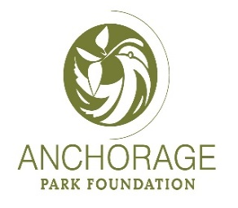

2022 Anchorage Park Foundation Community Challenge Grant Application

Applicant Type: Select one.
Individual
Nonprofit
School
Community Council
Sports Organization
Service Organization
Business
Other

Project Lead Contact Information
First Name
Last Name
Email
Mobile Phone
Address
City
State
Zip

Project Name (short sentence)
The project name should reference the park, trail or facility that is the focus of the project as well as the type of grant-funded capital improvement work to be accomplished. For example: “Chester Creek Trail: Wayfinding signage” or “construct a trail” or “remove invasive species”

Project Location and Address
Name of park, trail or facility
Address
City
Zip

Project Description (1000-character limit)
What do you want to do? (Example: tree planting, trail improvements, signage, etc.)

Public Benefit (500-character limit)
Who will benefit from the proposed project? What is the identified public need?

Partnerships and Community Support (1000-character limit)
Partnerships and community support help define the benefit to the public. Examples include letters from your community council, a pledge from a local business, partnership with a school, nonprofit, etc.

Project Budget Narrative (1000-character limit)
(Download and complete the required Project Budget Template. Choose from two templates that can be found online at Anchorage Park Foundation website here)
The narrative helps describe the required project budget spreadsheet. Please include:
Total Project Budget $
Amount Requested from APF $
Matching Funds $
Example: Matching funds will be raised through donated labor at three volunteer events planned for 2022. Cash will be raised through one fundraising event in 2022, one fundraising event in 2023 and a grant from my community council in 2023.

Project Team (1000-character limit)
Please provide names and responsibilities of additional project team members, if applicable. Example: Do you have a landscape architect volunteering with you? A Scout Troop working with you? Does your team reflect community diversity?

Planning and Implementation (1000-character limit)
What major steps or phases are anticipated? How much time will each phase take? If your project can be completed in 2022, all the better. No need to wait until 2023 to complete.

Project Certification
To the best of my knowledge all the information in this application and each attachment is true and correct.

Digital Signature
First Name
Last Name
Date

Submitting Application
For questions and to submit all grant application materials, please contact
Diana Rhoades, Anchorage Park Foundation Community Engagement Director
907.249.6652, Diana@AnchorageParkFoundation.org

